Name: |  | ___________________________________________________ |  |  |  |  |  | Date: ___________
 |  | Subject :Year 11 Applications  Test 6, 2016  Topics – Linear equations, simultaneous equations, piece-wise functions and step graphs |  |  |  |  |  | 50  = %
Total Time: |  | 58 minutes
Total Reading: |  | 5 minutes
Total Working: |  | 53 minutes
Weighting: |  | 8% of the year.
Equipment: |  | SCASA Formula Sheet; 1 page notes (A4 double side) unfolded, Classpad; Scientific Calculator
SECTION 1: CALCULATOR FREE
Time: |  | 20 minutes |  | Marks for Section 1: |  | 16 marks
Reading: |  | 2 minutes |  | Equipment Allowed: |  | Nil
Working: |  | 18 minutes
1. | [ 4 marks: 1, 1, 1, 1]  Solve the following equations:
 | - 5x + 3 = 63 |  |  |  | - -7 – 2y = 23
 | - $\frac{9-2x}{3}=7$ |  |  |  | - 5h + 13 = 2h – 2
2. | [ 2 marks]  The sum of three consecutive integers is 144. Determine each of the integers.
3. | [ 3 marks: 1, 2]  The cost of hiring a limousine for the year 12 ball is $175 plus $3.50 for each kilometer travelled.
 | - Construct a formula to calculate the cost of hiring a limousine with this company
 | - Calculate the cost of hiring a limousine to travel 20 km.
4. | [ 4 marks: 1, 1, 2]  Graph the following linear functions on the number plane provided:
 | - x = 5 b) y = ½ x |  |  |  | c) 2x – 8y = 20
 | 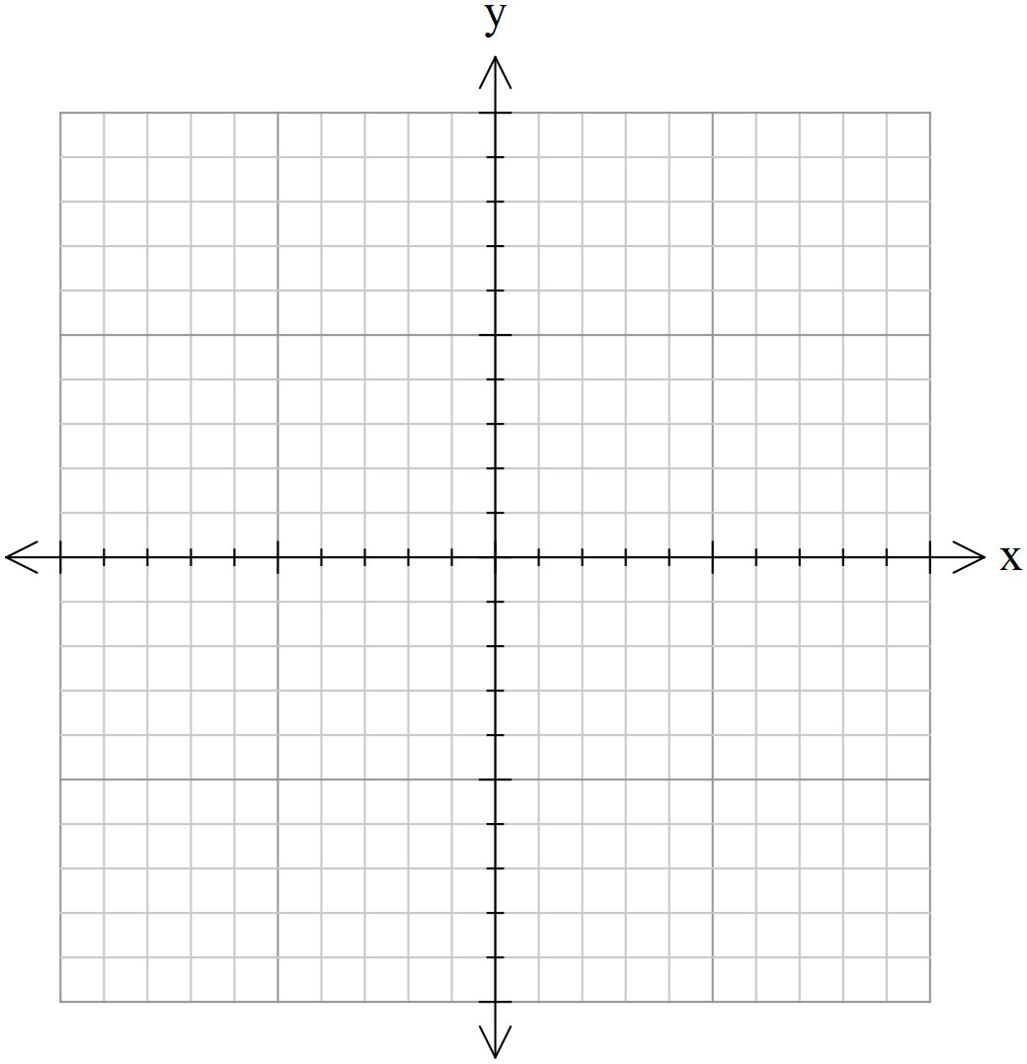
5. | [ 2 marks: 1, 1]  Write the linear equation for the following table of values:
 | a)  x 0 1 2 3 4 5  y 1 5 9 13 17 21 |  | b)  x 6 7 8 9 10 11  y 8 10 12 14 16 18
6. | [ 3 marks: 1, 2]  Solve the following simultaneous equations:
 | a) y= 2x + 6  y + 3x = -4 |  |  |  | b) 10x + 11y = 39  5x – 22y = 47
~ END OF TEST SECTION 1~
Name: ____________________________________ |  |  |  |  |  |  | Date:
SECTION 2: CALCULATOR ASSUMED

Time: | 38 minutes | Marks for Section 2: | 34 marks
Reading: | 2 minutes | Equipment Allowed: | SCSA, FormulaSheet, 1 page notes(A4 double side), Classpad, scientific calculator
Working: | 36 minutes

7. [ 5 marks: 1, 1, 3]
The value (V) of a car t years after it is purchased is given by the equation V = 350 – 10t.
- Find the value of the car when it was new

- After 5 years

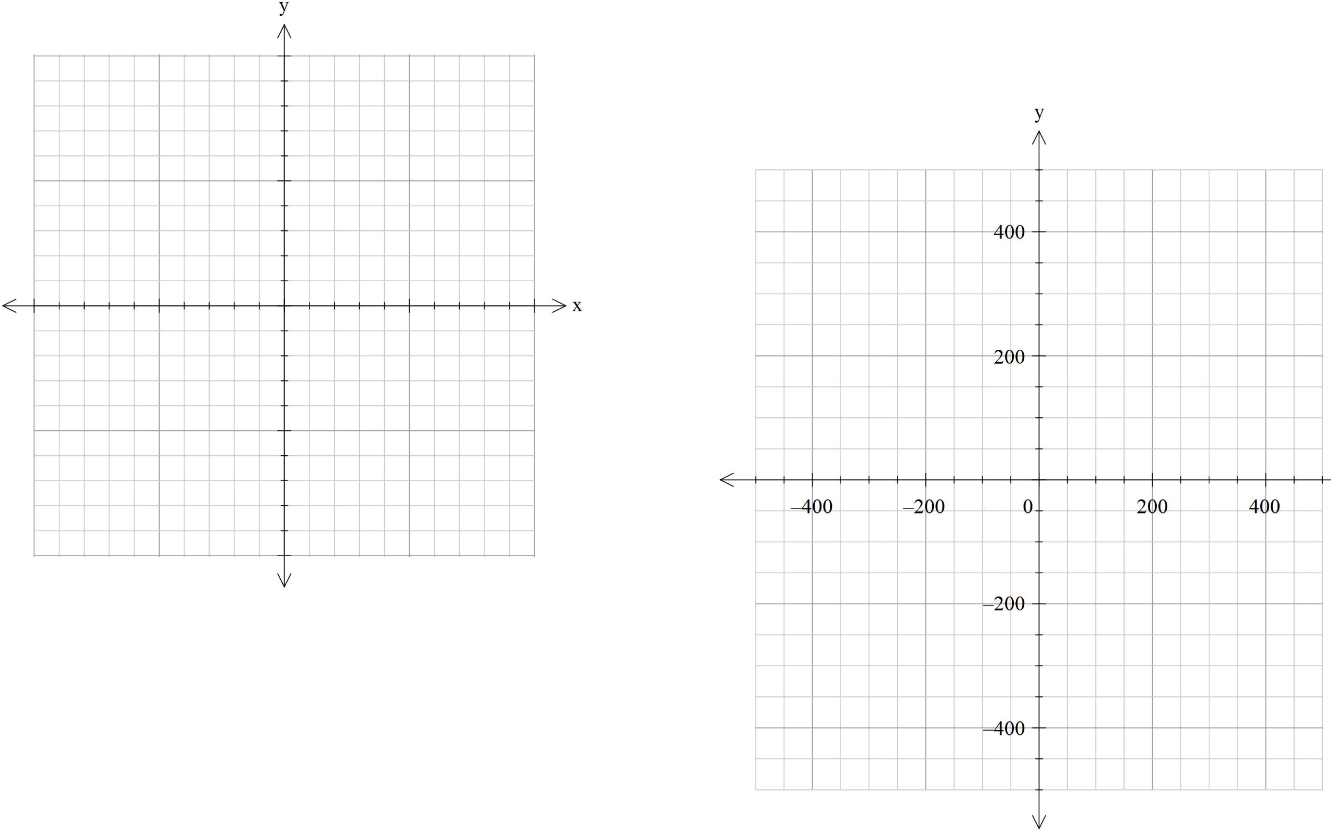
- Plot the relationship.

8. [ 3 marks]
A swimming pool is being filled at a constant rate so that after 4 hours it contains 5000 litres, and 3 hours later it contains 9500 litres. Write an equation representing this relationship, letting V be the volume in the pool after t hours.
9. [2 marks: 1, 1]
Find the equations of the line that passes through the points below:
- (-1, 3) (0, 4)

- (-2, -2) (0, 2)

10. [ 2 marks: 1, 1]
Find the equation of the line given the gradient and one point:
- m= 6 (-1, 5)

- m= -2 (0, 3)

11. [ 2 marks: 1, 1]
Find the equation of the line from the following graphs:
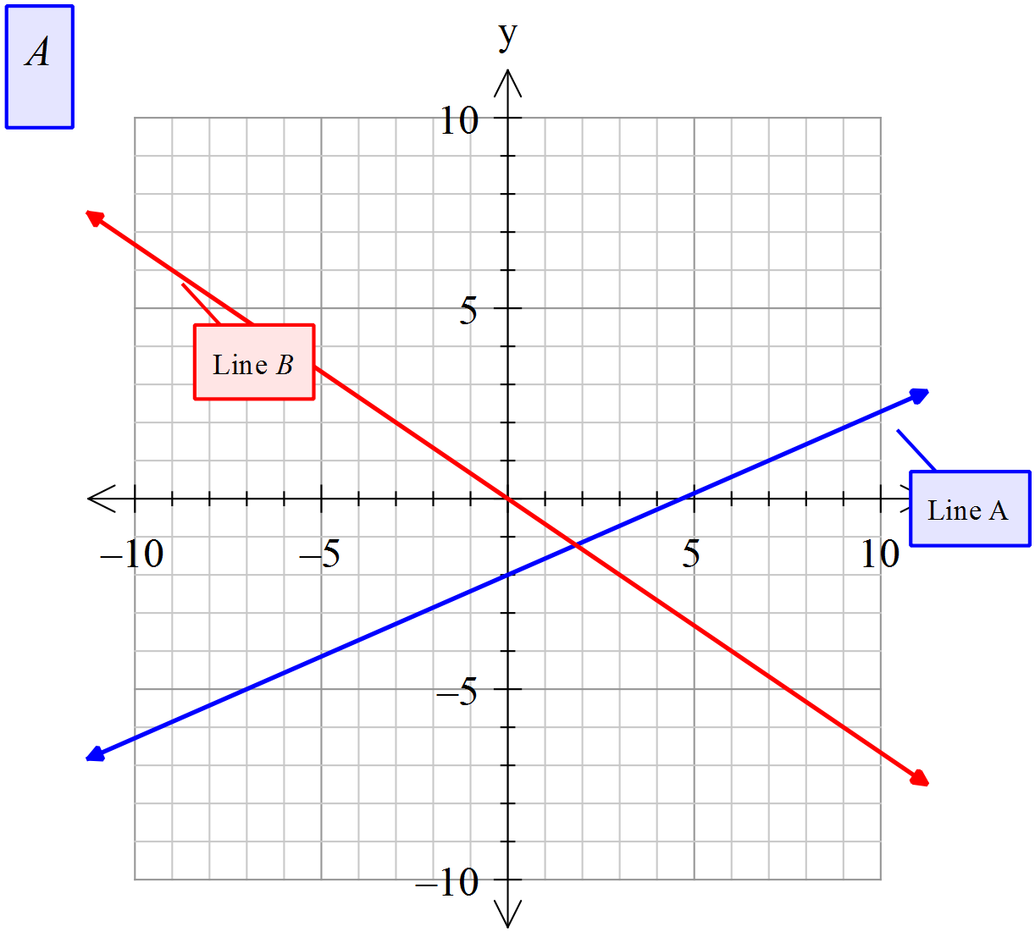
- Line A | - Line B
12. [ 4 marks: 2, 2]
The year 12’s are looking at transportation to their school ball. A hummer limo can carry 10 people, and a normal taxi can carry 2 people. There are 40 people that need transportation, and they need 8 vehicles for safety requirements.
a) Write the simultaneous equations for this information

b) Find the number of hummer limo’s and taxi’s they will need
13. [11 marks: 2, 6, 3 ]
A real estate agent charges the following commission rates for selling property.
- 8% of the first $70 000 of the properties price
- 5% of the next $80 000
- 3.5% of the remaining amount

- Complete the table of values using the rates given above:
Property price ($P) | 0 | 70 000 | 150 000 | 800 000
Commission (C)

- Use the table above to help you draw a piecewise graph displaying the agents commission for property values from $0 to $800 000
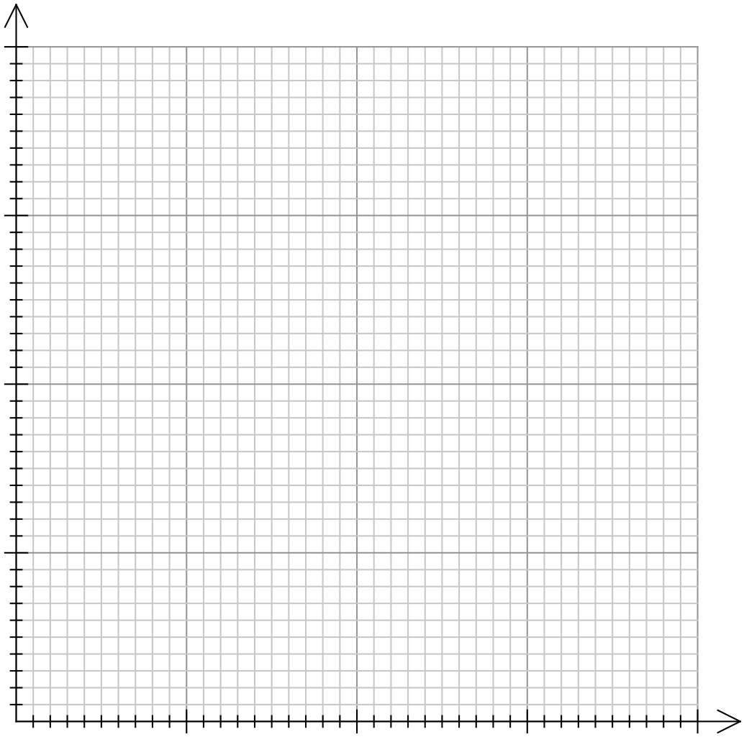

- Find the commission earned for selling:
- A unit for $115 000

ii. A house for $370 000

iii. A farm house and land for $730 000
14. [5 marks]
Graph the following step graph, showing the cost ($C) for the number of hours (n) spent in a car park:
$$C=\left\{\begin{aligned}\$15, for 0<n ≤4 \\ \$6.80, &for 4<n ≤6 \\ \$4.50, &for 6<n≤9 \\ \$2.20, &n>9\end{aligned}\right.$$
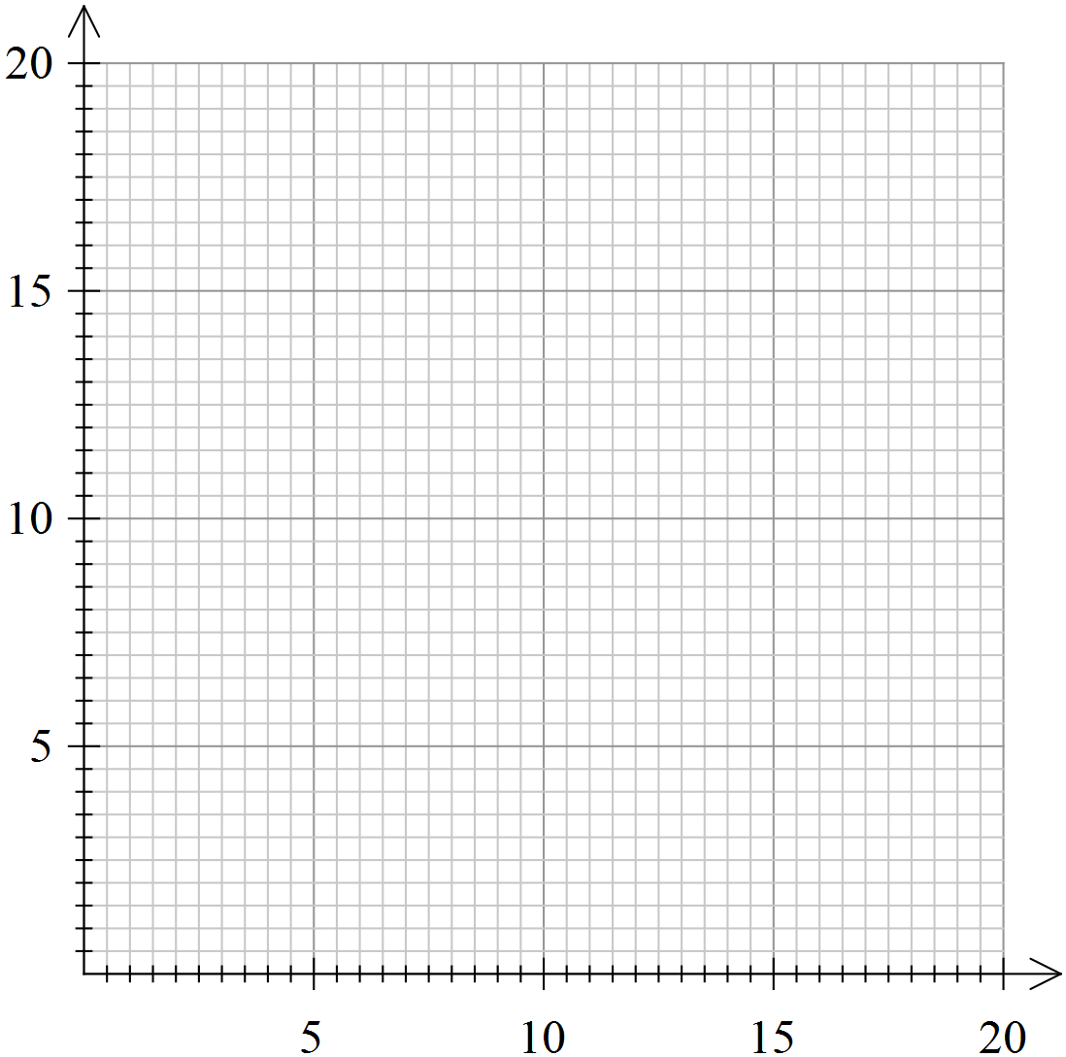
~ END OF TEST SECTION 2 ~

